Practical No.14
Create a Simple REST Service to perform various string operations.
Step1: Using NetBeans create a new Web Application.
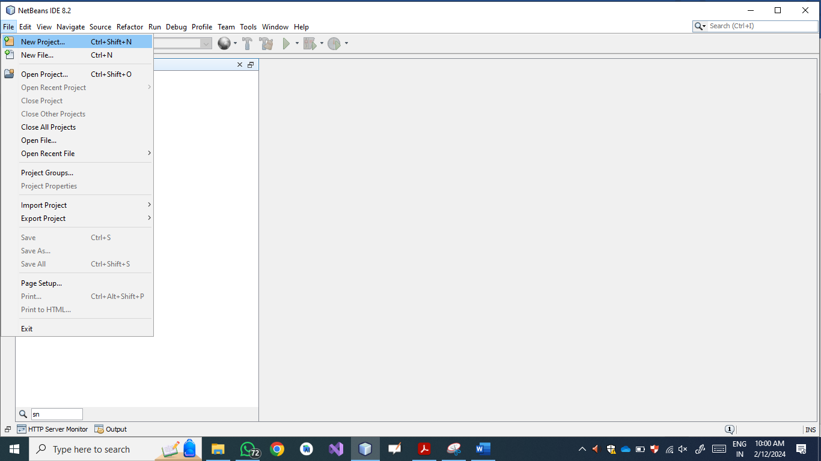
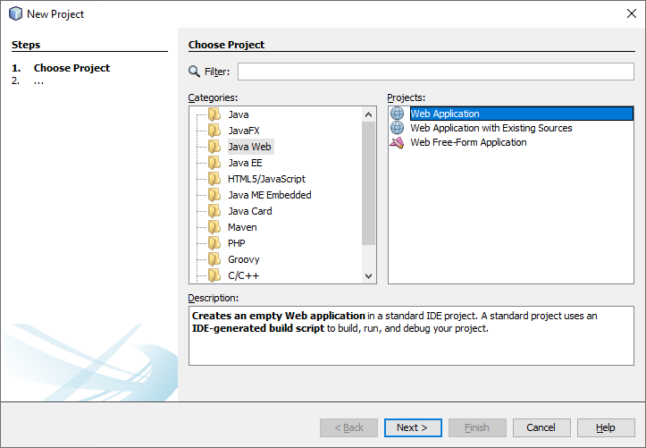

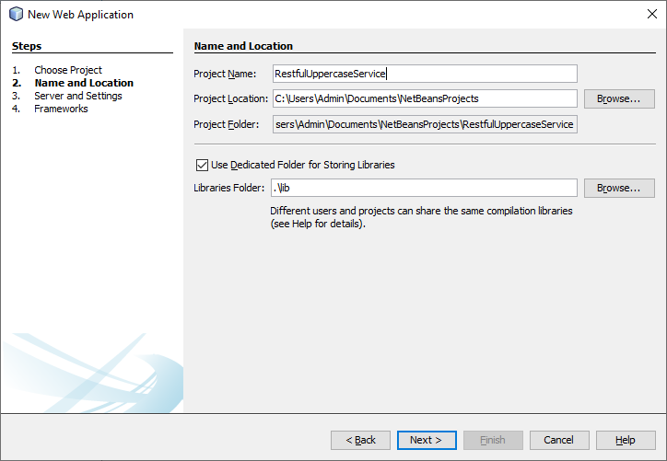
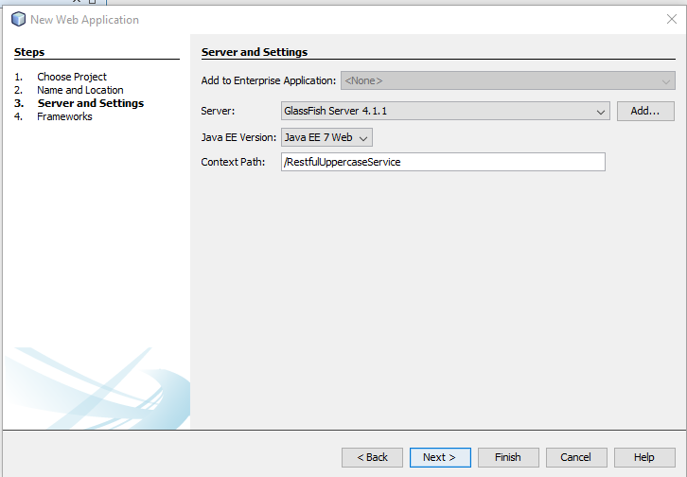
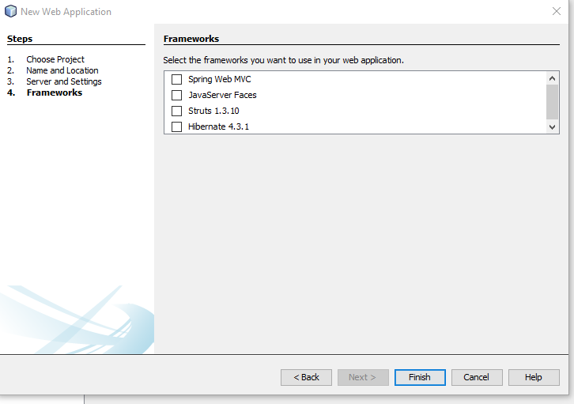

Step2: Create Restful Web service in Web application.

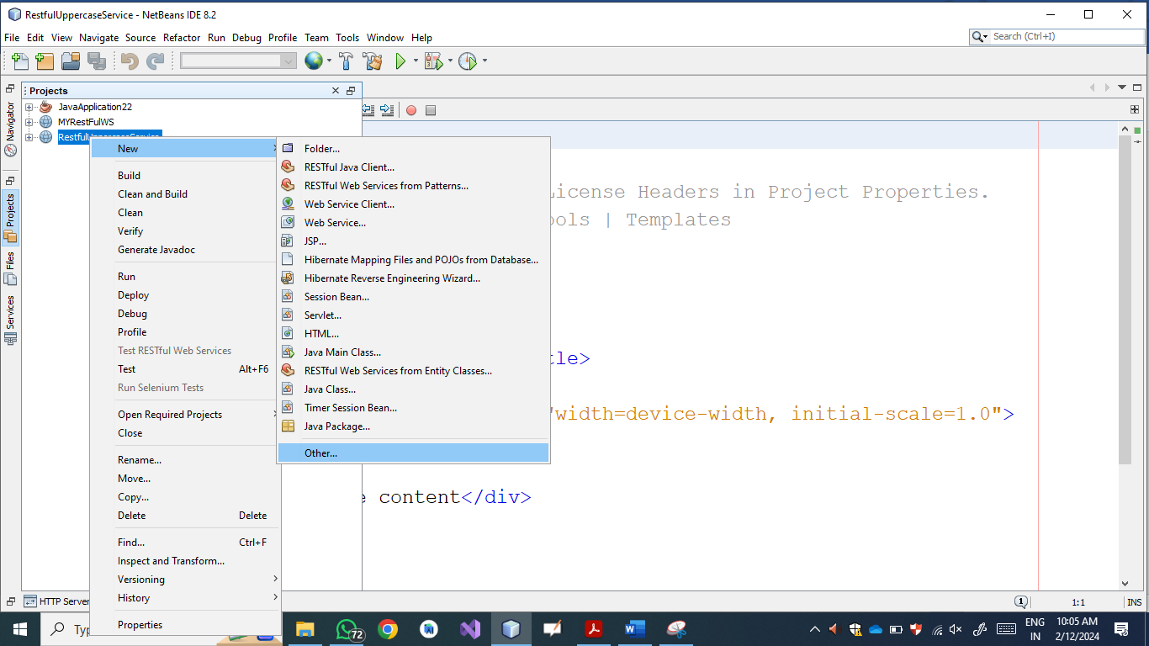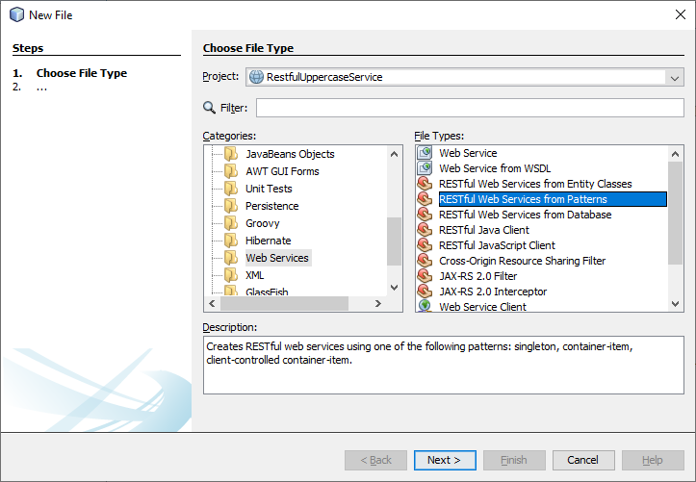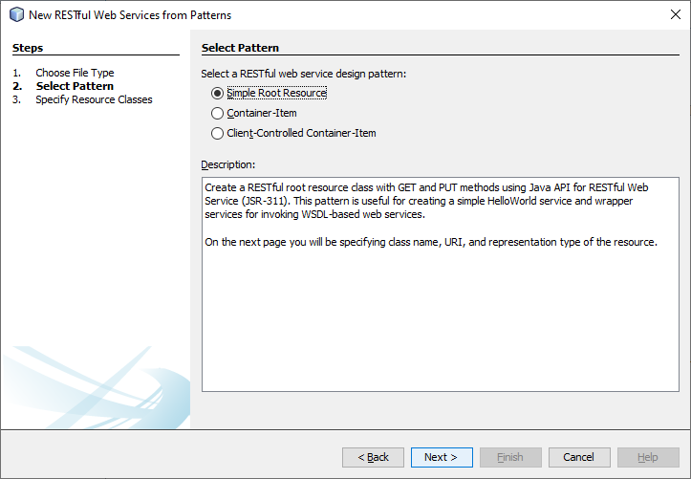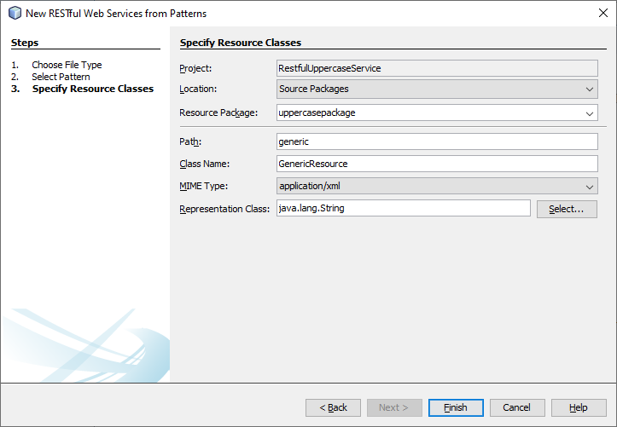
/*
* To change this license header, choose License Headers in Project Properties.
* To change this template file, choose Tools | Templates
* and open the template in the editor.
*/
package server;

import javax.ws.rs.core.Context;
import javax.ws.rs.core.UriInfo;
import javax.ws.rs.Produces;
import javax.ws.rs.Consumes;
import javax.ws.rs.GET;
import javax.ws.rs.Path;
import javax.ws.rs.PUT;
import javax.ws.rs.core.MediaType;

/**
* REST Web Service
*
* @author Administrator
*/
@Path("generic")
public class StringOperations {

@Context
private UriInfo context;

/**
* Creates a new instance of StringOperations
*/
public StringOperations() {
}

/**
* Retrieves representation of an instance of server.StringOperations
* @return an instance of java.lang.String
*/
@GET
@Produces(MediaType.TEXT_HTML)
public String getHtml() {
//TODO return proper representation object
throw new UnsupportedOperationException();
}

/**
* PUT method for updating or creating an instance of StringOperations
* @param content representation for the resource
*/
@PUT
@Consumes(MediaType.TEXT_HTML)
public void putHtml(String content) {
}

@PUT
@Consumes(MediaType.TEXT_HTML)
@Path("/Uppercase")
public String toUppercaseMethod(String str)
{
return str.toUpperCase();

}

@PUT
@Consumes(MediaType.TEXT_HTML)
@Path("/Lowercase")
public String toLowercaseMethod(String str)
{
return str.toLowerCase();

}
}
Output
First Clean the Web Application, then deploy the web application and finally test the web service as follows
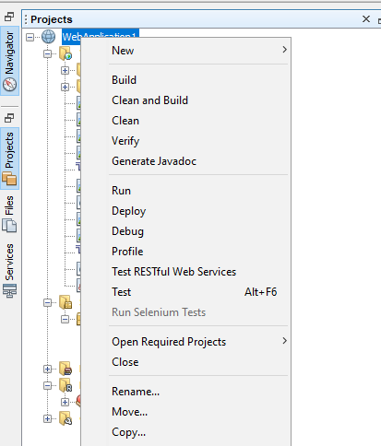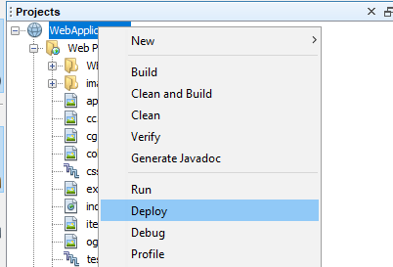
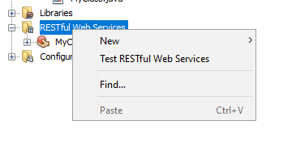

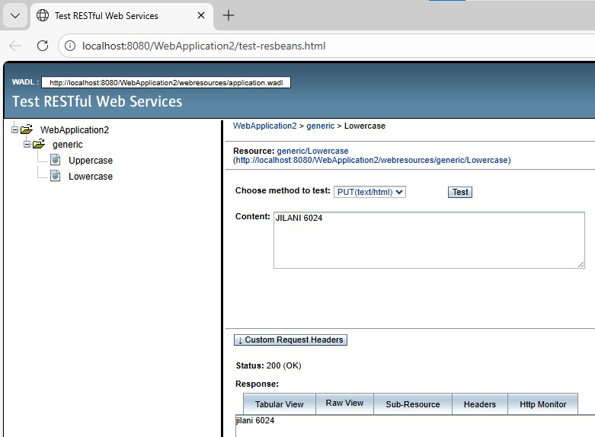

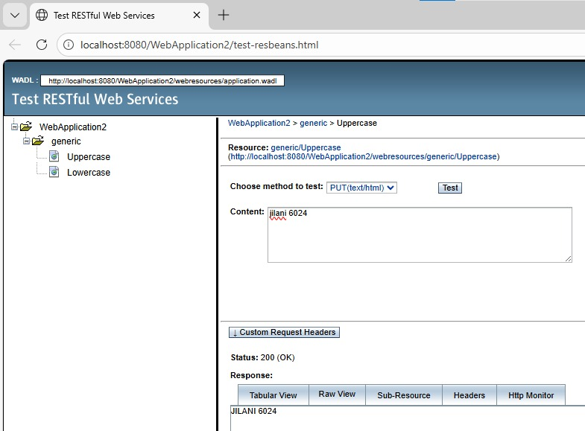

Restful Client
Code
/*
* To change this license header, choose License Headers in Project Properties.
* To change this template file, choose Tools | Templates
* and open the template in the editor.
*/
package restfullclient__jilani6024;

import Client.StringOperations;

/**
*
* @author Administrator
*/
public class RestFullClient__Jilani_6024 {
/**
* @param args the command line arguments
*/
public static void main(String[] args) {
// TODO code application logic her
Client.StringOperations client = new StringOperations();
System.out.println("Jilani 6024");
System.out.println("Lowercase Output :"+ client.toUppercaseMethod("MOTASHAM”));
System.out.println("Uppercase Output :"+ client.toLowercaseMethod("mohtasham"));
} }
Output
